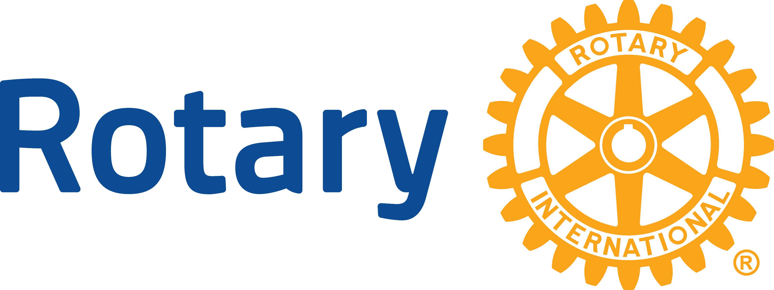

ENDOWMENT FUND GRANT GUIDELINES

FOR

THE ROTARY CLUB OF MUNCIE

The Board of Directors of the Rotary Club of Muncie considers grant requests annually. The Board wishes to evaluate all requests as objectively as possible, consistent with the expressed priorities   
of the Club. Please review the general guidelines listed below when considering your request   
for charitable funding.

**Timeline:**

* Requests must be submitted no later than August 31, 2025.

**Local Focus:**

Requests will be considered for review based on the following community priorities:

* Education
* Arts/Culture
* Human Services
* Economic Development
* Community Betterment

The Muncie Noon Rotary Club will generally not consider:

* Multi-year commitments
* Support for individual political parties/candidates or support for religious teachings and programs.
* Support for operating or budget deficits, capital campaigns, endowments, or to benefit individuals.

*The Rotary Club of Muncie was organized on July 13, 1917*

**ROTARY CLUB OF MUNCIE**

**P.O. BOX 1033**

**Muncie, IN 47308**

**GRANT APPLICATION**

**Deadlines:** The application with attachments must be electronically received or postmarked   
by 5:00pm on August 31, 2025.

**Send To:** [MuncieRotaryClub@gmail.com](mailto:MuncieRotaryClub@gmail.com)

or

Rotary Club of Muncie

Attn.: Grants Committee

P.O. Box 1033

Muncie, IN 47308

**Name of Organization:**

**Federal Tax ID number (EIN):**

**Primary Contact: Title:**

**Address:**

**Phone: Email: Fax:**

**Summary** of proposal, including objectives:

**Pertinent Dates Involved**:

**Total cost of the project** $

**Requesting from Rotary** $

(Project budget must be attached to this application)

**Other funding sources for this project:**

Funding Source Total Request Status

**Organization’s total operating budget:**

**Future Funding:** What are the plans for future funding for this project?

**Community Betterment:** What are the benefits of this project to our community?

**Partnership:** How can Muncie Rotary volunteer to help complete this project?

**Eligibility:**

* Tax-exempt charitable organization – IRS 501 ©(3)
* Affiliated with tax-exempt organization or governmental unit
* Other – please explain:

**Fiscal Year:** to

**Outside Audit:** Does your organization have an annual audit?

If no, please explain:

**Signature** of chief staff person and officer of the Board of Directors indicating board approval of the request and certifies the organization’s commitment to file appropriate reports on the grant’s use.

Name: _______ Name: _______

Signature: ________________________ Signature: ________________________

Title: _______ Title: _______

**Attachments**

Your proposal should contain the following information:

* IRS determination letter (if applicable) – verifying tax exempt status
* List of Board of Directors
* Most recent Financial Statements
* Detailed Project Budget

**Notification**

Organizations will be notified no later than September 30, 2025.

**In Conclusion**

When reviewing all grant requests, the Selection Committee will apply the following:

**Rotary Four-Way Test**

Of the things we think, say, or do.

* **Is it the truth?**
* **Is it fair to all concerned?**
* **Will it build goodwill and better friendships?**
* **Will it be beneficial to all concerned?**